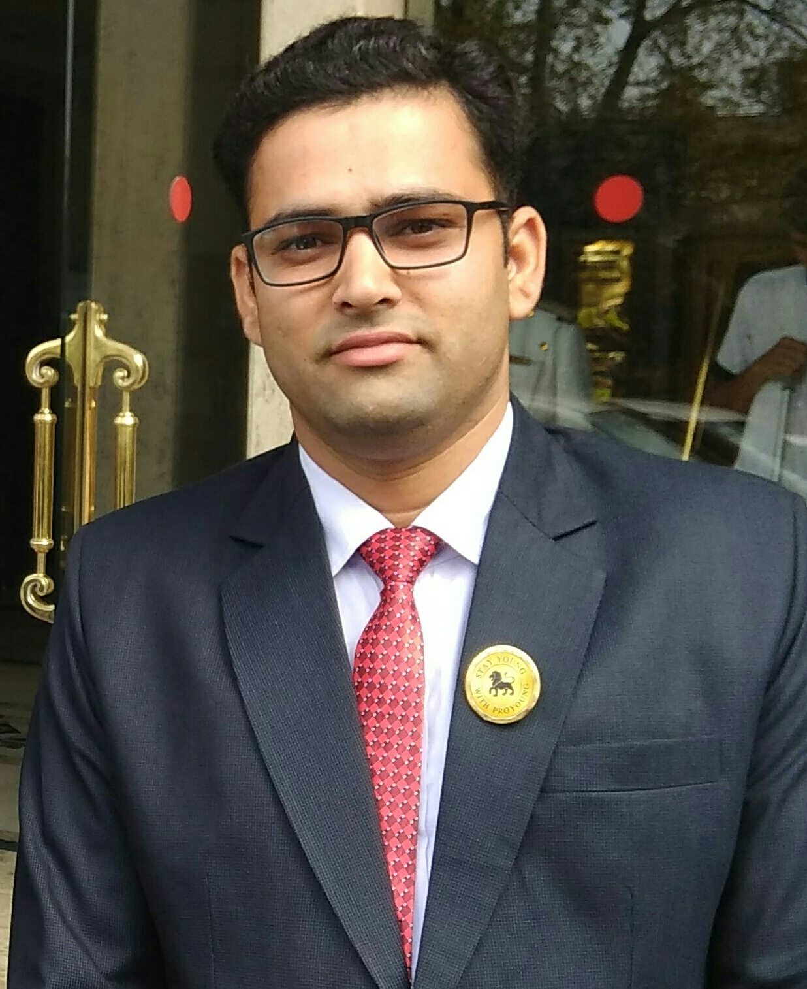
JECRC
Affix and Attest
passport
size photograph
JAIPUR

INDIVIDUAL TECHNICIAN DATA SHEET
Name of the Technical staff member | : | Sandeep sharma
Present Designation | : | Lab Instructor
Email Id: :Sandeep.sharma.8361@gmail.com
Contact Details :9680453697

I. Particulars of Educational Qualification: (only completed)

Category | Name of the Degree | Specialization | Year of Passing | Name of the College | Name of the University
ITI | ITI | Fitter | 2009 | Vishalakshi,ITC, jaipur | BTER
Diploma | Diploma | Mechanical | 2017 | Gurukul Polytechnic College, Jaipur | BTER

II. Academic Experience : 5 Year

III. Industrial Experience : 2 YEAR

